**Exploring the Causes of Medical Errors Based on Human Factors Analysis and Classification (HFACS) in Hospitals**

Mostafa Mirzaei Aliabadi1, Hamed Aghaei2, Ali Reza Soltanian3, Mohammad Javad Golhosseini4, Esmaeil Zarei5, Mohsen Yazdani Aval4, Sajjad Deyhim4, Shiva Soury6*

1 Center of Excellence for Occupational Health, Occupational Health and Safety Research Center, School of Public Health, Hamadan University of Medical Sciences, Hamadan, Iran

2 Department of Occupational Health Engineering, School of Public Health, Arak University of Medical Sciences, Arak, Iran

3 Department of Biostatistics and Epidemiology, School of Public Health, Hamadan University of Medical Sciences, Hamadan, Iran

4 Student Research Committee, Hamadan University of Medical Sciences, Hamadan, Iran

5 Department of Occupational Health Engineering, School of Public Health, Mashhad University of Medical Sciences, Mashhad, Iran

6 Department of Occupational Health and Safety Engineering, Faculty of Health, Ilam University of Medical Sciences, Ilam, Iran

* Correspondence: Department of Occupational Health and Safety Engineering, Faculty of Health, Ilam University of Medical Sciences, Ilam, Iran

E-mail: [ssoury93@gmail.com](mailto:ssoury93@gmail.com)

**Exploring the Causes of Medical Errors Based on Human Factors Analysis and Classification (HFACS) in Hospitals**

**Abstract**

**Background**: Attention to patient safety is one of the essential foundational to promote health services and it is important to identify the factors that contribute to medical errors. This paper aims to develop a questionnaire based on the human factors analysis and classification system (HFACS) for the first time.

**Methods**: A questionnaire was designed based on the HFACS structure. The Likert scale were utilized to score each item. The contribution of the main levels and sublevels in each error and also the correlation coefficients between different levels of HFACS with the lowest level (Unsafe Act) were determined.

**Results**: The number of medical errors in the emergency department, intensive care unit (ICU) and Cardiac Care Unit (CCU) were higher than the other departments. Insufficient supervision, management processes and adverse mental state achieved the highest scores. The Pearson's correlation coefficients show very strong relationships between organizational processes and supervisory violations with routine violations (0.81, and 0.84 respectively).

**Conclusions**: Organizational failures are the main cause of decreased patient safety and the mental condition of staff has the greatest impact on reduce medical errors.

**Keywords**: Hospital, HFACS, Medical Errors, Patient Safety.

**Introduction**

Today’s, as patient safety is a critical matter as worker safety, paying more attention to patient safety is one of the essential foundational to promote health services. In this way, the simplest definition of patient safety can be introduced as “those activities that may reduce the risk of adverse events related to exposure to medical care across a range of diagnoses or conditions” (1). Although the health care system has become more effective, it has also become more complex, with greater the use of new technologies, medicines, and treatments. Recent studies showed that in Australia and America, 16.6% and 3.7%, respectively, of patients who were hospitalized had complications due to medical errors (2). Thus, failure to prescribe medication can cause complications that can be prevented (3). Here, a drug error that may occur in the operating room, can be very problematic in the patient's anesthetic process (4). It is important to identify the factors that contribute to medical errors in certain situations, such as covid-19 pandemic.

In a study conducted of 277 surgical procedures, of 3671 prescriptions, 193 drug errors (5.3%) occurred. They also found that 79.3% of them were preventable (5). The developing strategies to achieve the experience from errors occurring in treatment centers requires accurate planning by managers to generate the conditions where employees can report errors without worries. Nevertheless, in recent years, several models have been developed to distinguish and reduce human errors (6, 7). One of these methods is the Human Factor Analysis and Classification System (HFACS) framework, which was initially introduced by Dekker as one of the most influential and practical tools to survey different types of incidents (8). This model has initially been provided for the analysis and classification of operator errors in aviation and maritime accidents, based on the Reason model, which was introduced to identify the human error in air traffic accidents. According to Reason, errors are categorized into two groups, active errors, and latent errors, based on which the active errors occur at the point of contact between a human and some aspect of a larger system. In contrast, latent errors denote less apparent failures of organization or design that contributed to the occurrence of errors or allowed them to cause harm to workers (9).

The structure of the HFACS is defined in four levels in a hierarchical manner. The four main levels include unsafe acts, preconditions for unsafe acts, unsafe supervision, and organizational influences. Each level is related to the previous level, and the reasons for the error are arranged from active to latent situations in a hierarchical manner from unsafe acts to organizational influences. A better explanation of the HFACS framework is illustrated in figure 1 (10).

HFACS is well known as a framework for to investigate some field such as the railway accidents (11) as a model to illustrate the roots of errors in mining (12-14), oil and gas (11), construction (15), health care(16) , surgical procedures (17) , and as a tool for reducing occupational accidents in the shipyard has been used (18).

Boquet et al. described the HFACS system to distinguish the causes of both active errors and latent errors in medical emergencies. In this way, they found that the highest percentage of errors were related to skill-based errors (69%), decision errors (31%), and perceptual errors (26%) and violation errors (15%) (19). On the other hand, in a study on 545 incidents in the airline industry using the HFACS method, it was found that at the Level 1 skill-based errors, at the Level 2 adverse mental state, at the Level 3 Inadequate supervision and at the Level 4 resource management has been the most effective factor in accidents (20).

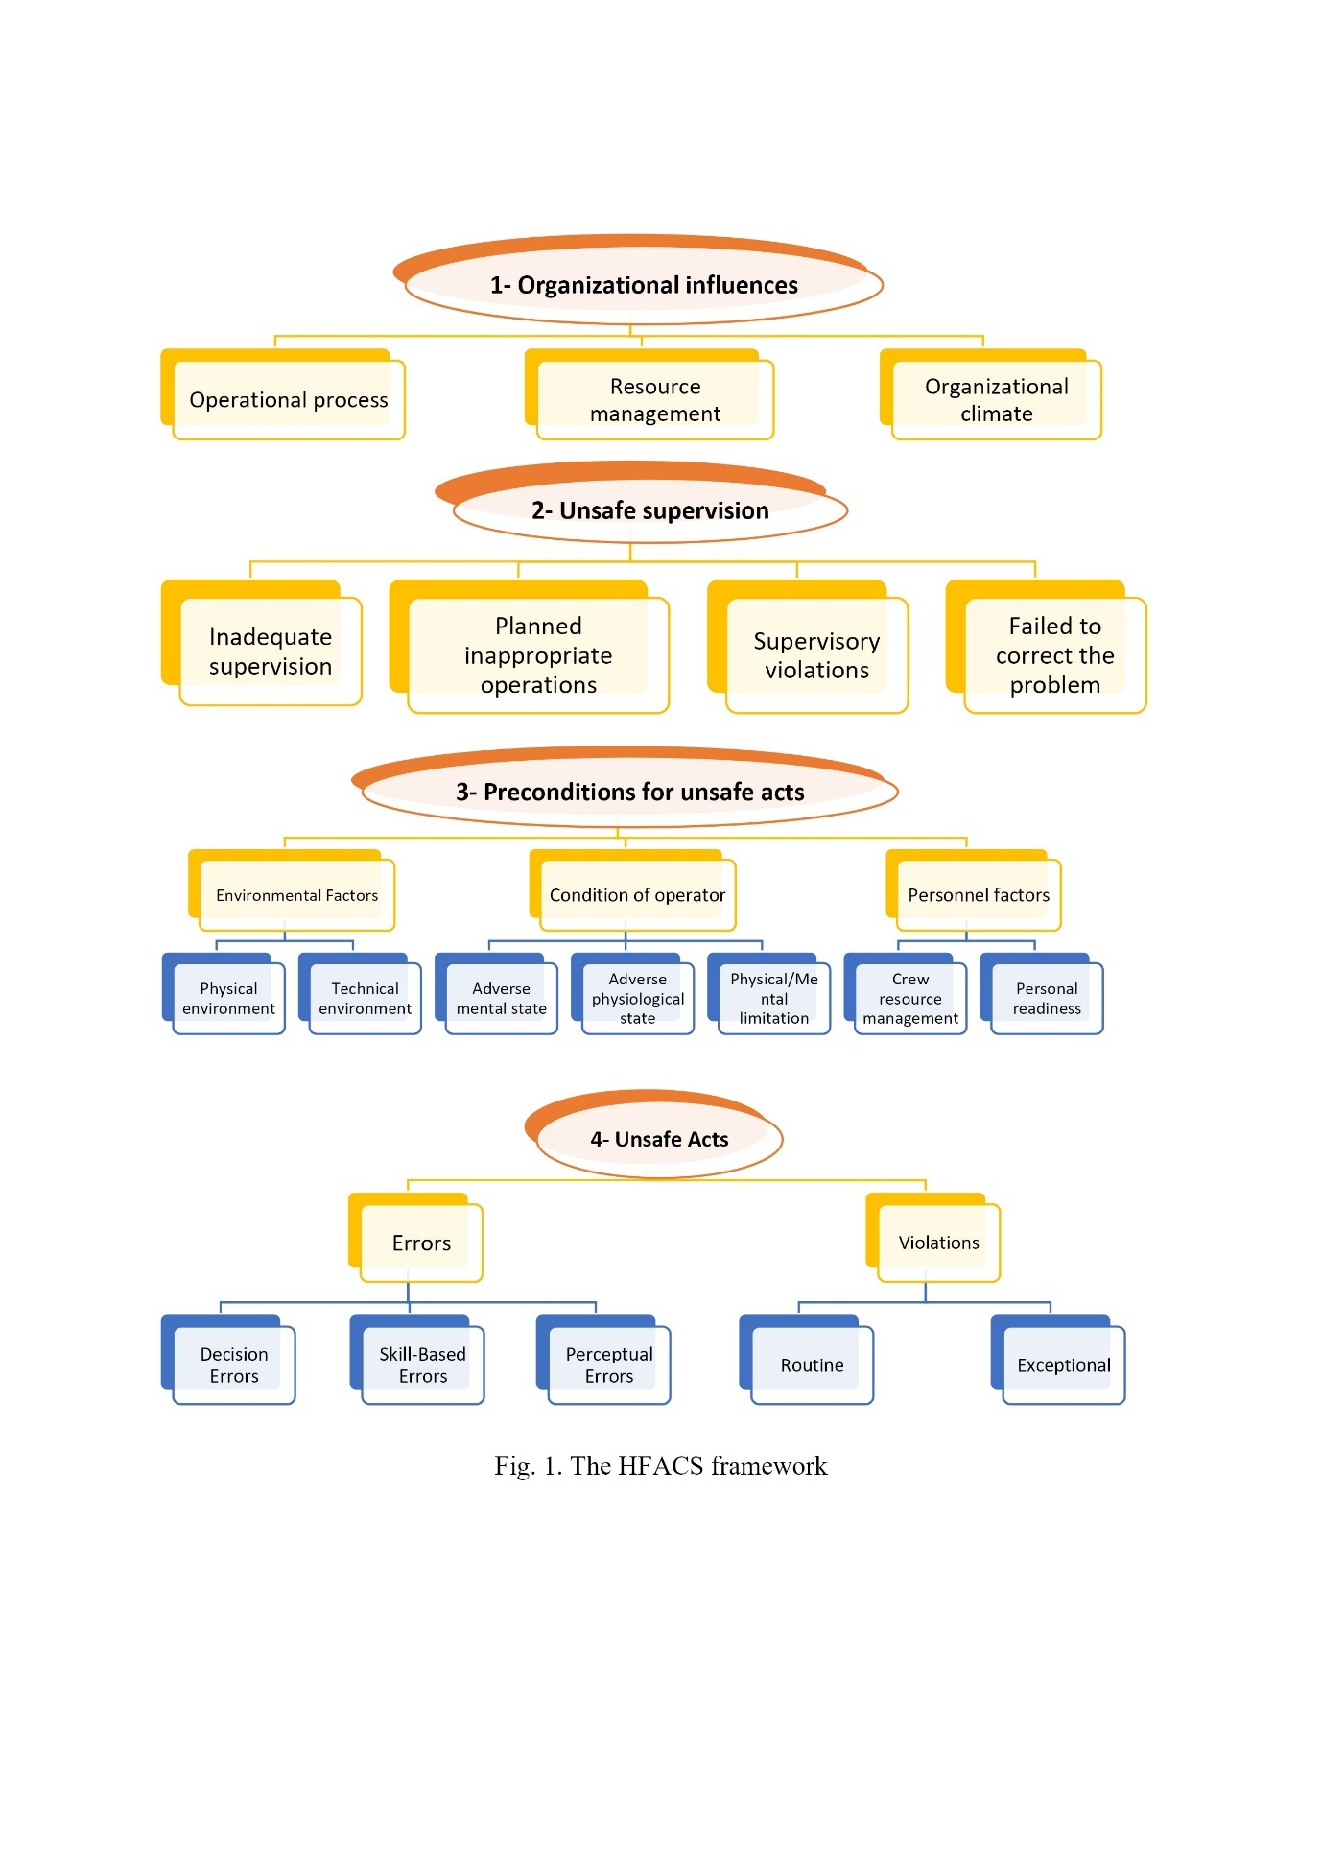

Fig. 1 The HFACS framework

Here, it should be noted that when a medical error occurs, an active error could be detected immediately. Nevertheless, are there any latent errors? As long as there are latent causes, even if we remove the causes of the active error, we should expect other errors at other places and times. Now, the HFACS tool has acceptable inter and intra-rater reliability for assessment of accident (21), which reveals that this method has the value of training and implementation in the health care system.

As we need the right tools to appropriately identify the causes of both the active and latent error, this paper aims to develop a questionnaire based on the principles of the HFACS method to distinguish the main and critical causes of human error in the treatment process as well as to determine causes of the medical errors in a training hospital.

**Methods**

This study was approved by the IRB of our institution (IR.UMSHA.REC.1397.460) and was conducted in an educational hospital, including more than 1000 patient beds, 3000 medical staff members, and 10,000 employees. The medical errors that occurred from February to April 2020 were analyzed. The hospital policy is taken based on the identification and analysis of medical errors to enhance the patient safety policy. To do it, a questionnaire was designed based on the HFACS structure, which contains four main levels, 19 sublevels, and a total of 94 questions.

Both the validity and reliability of the questionnaire were assessed through 10 experts and the medical staff. Besides, to evaluate the reliability of the proposed questionnaire, the content validity method (CVR and CVI indices) was employed. Furthermore, the Cronbach's alpha coefficient was utilized to investigate the reliability of the questionnaire. Based on the study by ElBardissi et al., 359 medical errors were investigated (22).

It is worthwhile to mention that two trained experts through an interview filled out the proposed questionnaires along with doctors and nurses, in an educational hospital. Interviewees should answer each question based on medical errors that they either have carried out or have been witnessing.

To do it, the Likert scale and ranging were utilized to score each question, in which from very low=1 to very high=5. In this way, the contribution of the main levels and sublevels in each accident was specified, as each error usually has more than one cause, and the impact of each cause on the accident is different.

Ultimately, the subgroup scores at each level of HFACS were analyzed using SPSS-21 software. The following formula was employed to calculate the error score.

Where "a" denotes the sum of the scores given by participants to questions at each level, and "b" means the maximum points of each level (based on the Likert scale). For instance, suppose there are four questions for the skill-based error level, and participants scored five on each of these four questions, so a=4×5=20 and b=4×5=20 (the highest score on the Likert scale was considered five). As a result, the final score of the skill-based error sub-level becomes one (S= 20/20=1).

The sub-level relative score was then measured from the sum of the total score of the questionnaires. On the other hand, the score of the main-level was also achieved from the sum of its relative score of sub-levels. For example, the relative score of the "violation level" was calculated from the sum of the "routine" and "exception" sub-levels scores.

In addition, the SPSS software was implemented to elaborate the correlation coefficient between different levels of HFACS and the lowest level (unsafe act), as the level of "unsafe act" is immediately before the error.

**Results**

In the following, those questions with CVR and CVI of less than 0.7 were eliminated so that the number of questions decreased from 105 to 94. Meanwhile, in the analysis of reliability, the Cronbach's alpha coefficient was obtained as 0.721. In this study 42% of participants in this study had more than 5 years and 43% had between 5 and 15 years and the rest had less than 5 years of work experience. The most frequent errors were in the emergency department, Cardiac Care Unit (CCU) and intensive care unit (ICU) (31%, 24% and 32% respectively).

By investigating the questionnaires, it is revealed that each medical error has more than one cause. Besides, the relative score of each main-level of HFACS was measured to distinguish the contribution of causes. The results show that the relative scores of "unsafe supervision" and "organizational influences" are higher than other levels. The organizational influences level contains three sublevels, and the unsafe supervisions level includes four sublevels that their relative scores are exhibits in Figure 2.

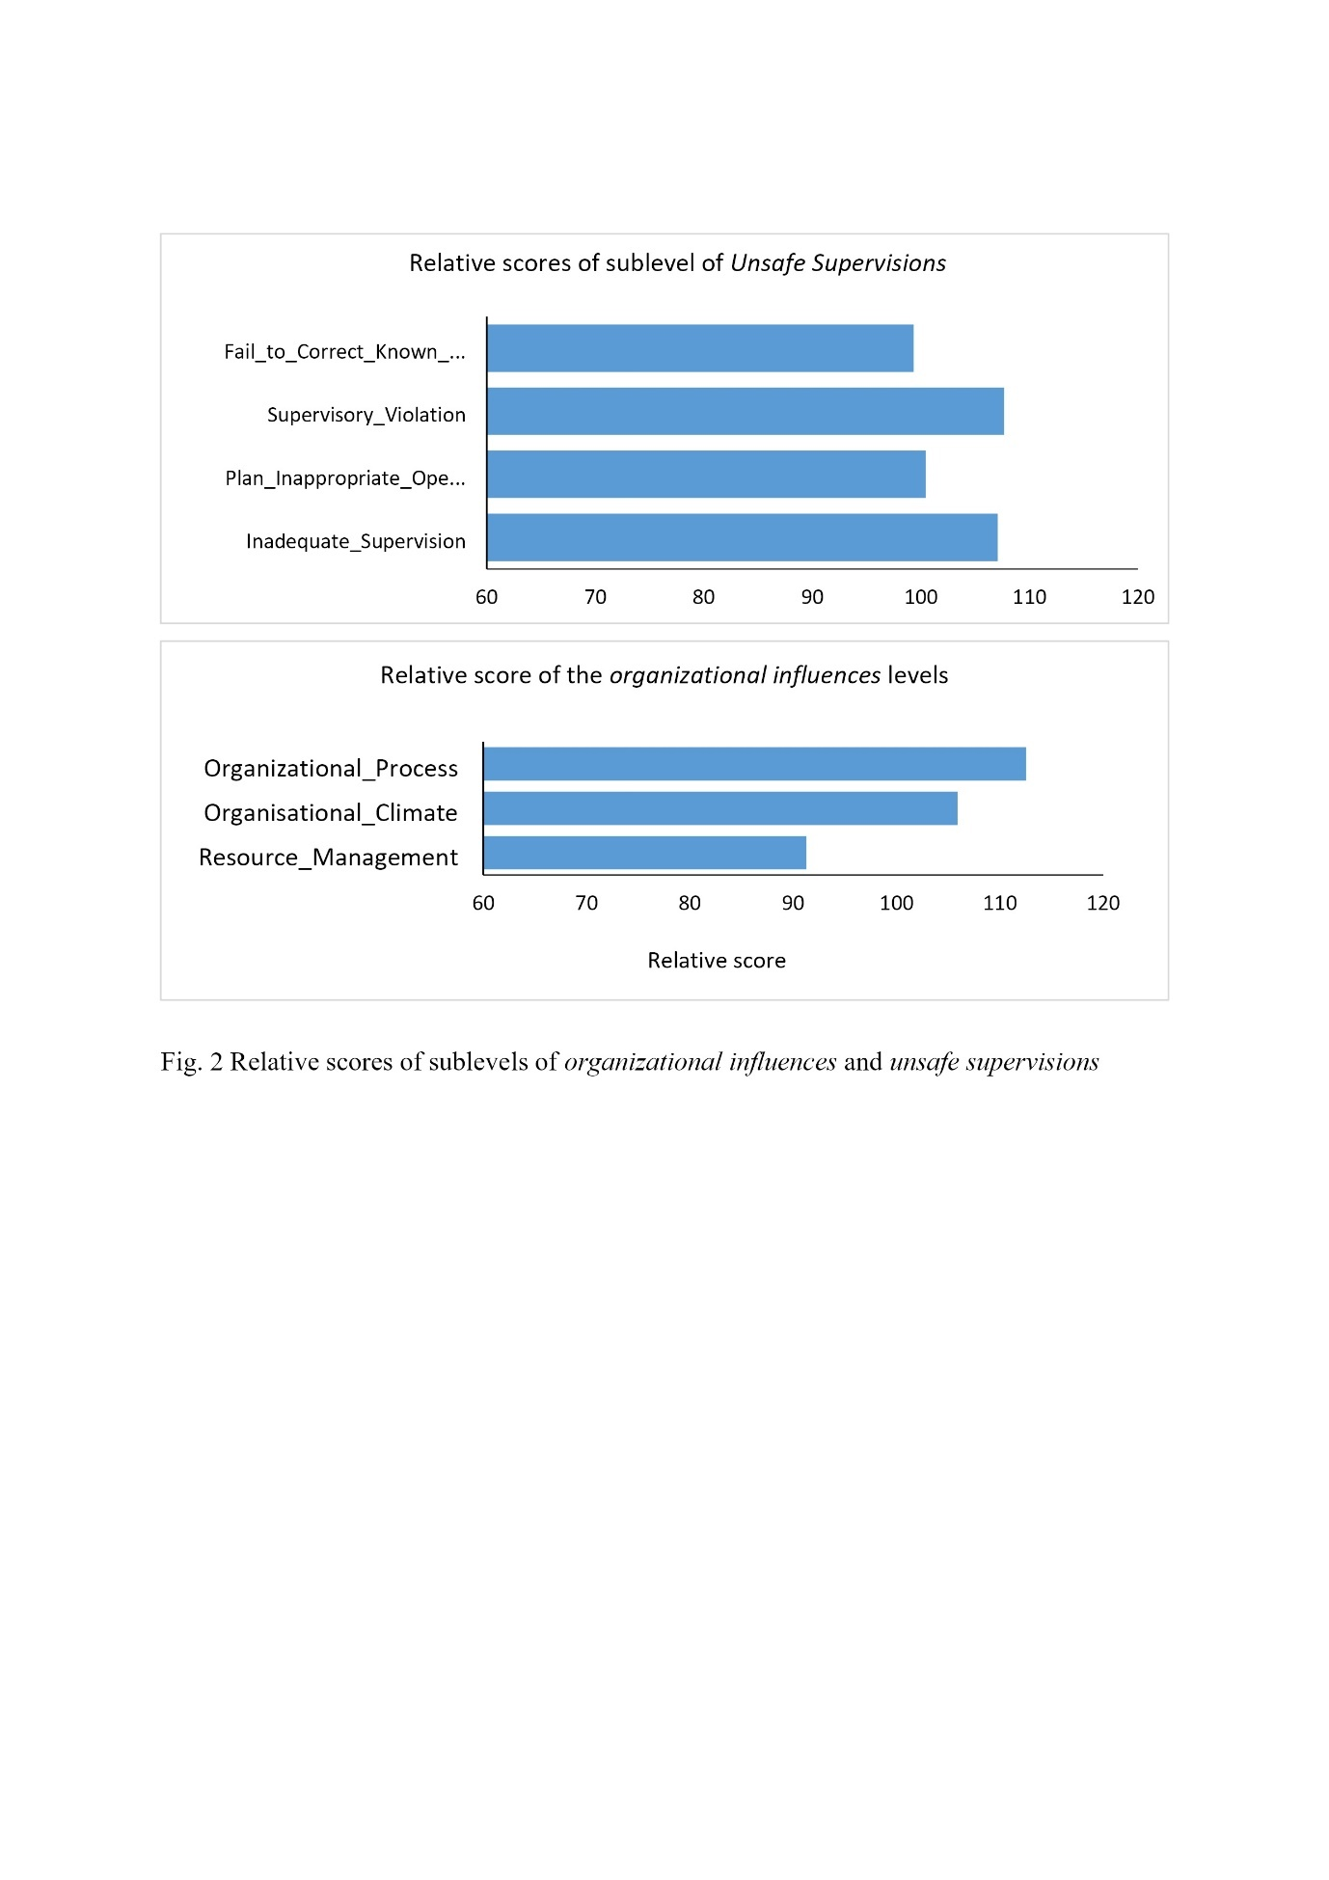

Fig. 2 Relative scores of sublevels of organizational influences and unsafe supervisions

Based on Figure 2, both the "organizational process" and the "supervisory violation" obtain the highest score. In this regard, to better understand the received experimental results, the relative score of all levels of the HFACS can be observed from Figure 3.

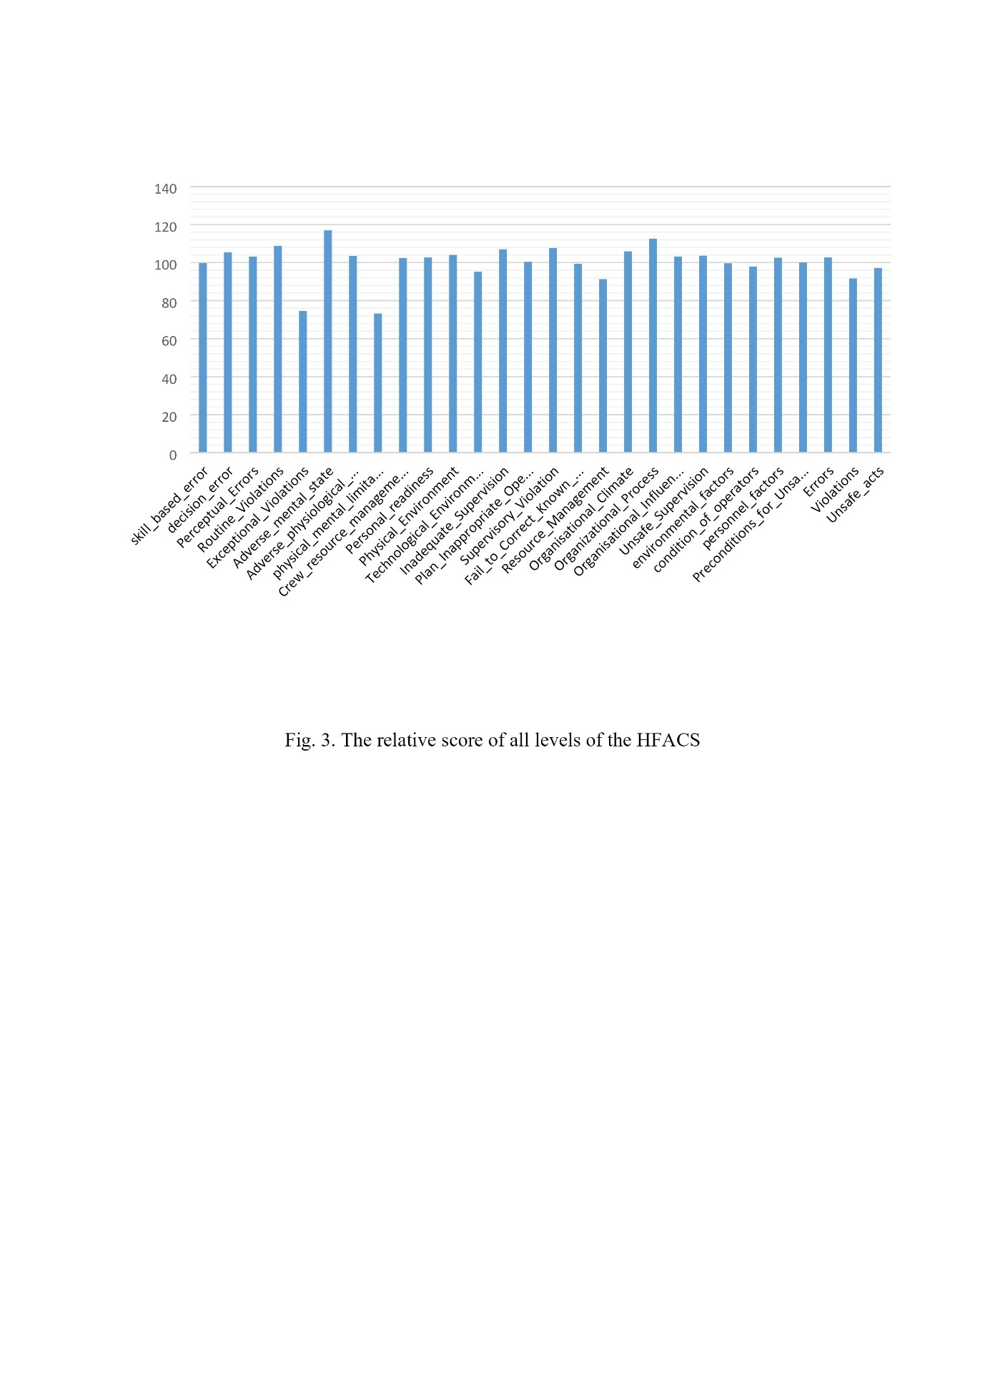

Fig. 3. The relative score of all levels of the HFACS

In the meantime, the Pearson correlation coefficients between main levels of HFACS are shown in figure 4.

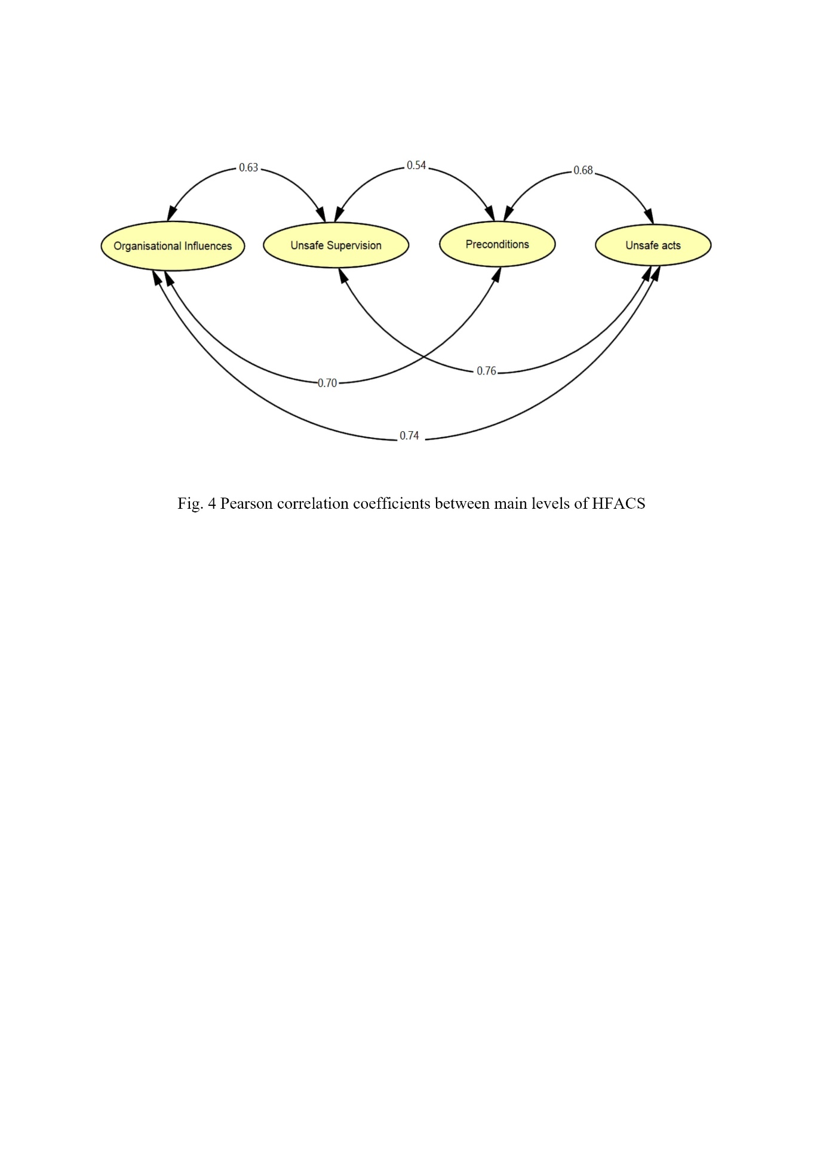

Fig. 4 Pearson correlation coefficients between main levels of HFACS

Here, to explore the relationships between the response’s sublevels, Pearson correlation coefficients were estimated, which are listed in Table 1.

Table 1. Pearson Correlation Coefficients between sublevels

|  |  |  |  |  |  |  |
| --- | --- | --- | --- | --- | --- | --- |
|  | | Unsafe Acts | | | | |
| Decision Errors | Skill-based Errors | Perceptual Errors | Routine | Exceptional |
| Organizational Influences | Resource Management | 0.73 | 0.61 | 0.66 | 0.12 | 0.18 |
| Climate | 0.75 | 0.70 | 0.73 | 0.73 | 0.65 |
| Process | 0.64 | 0.66 | 0.60 | 0.81 | 0.80 |
| Unsafe Supervision | Inadequate | NS | NS | NS | 0.54 | 0.41 |
| Planned | 0.81 | 0.65 | 0.48 | 0.55 | NS |
| Failed to correct | 0.42 | NS | NS | 0.77 | 0.68 |
| Supervisory violations | NS | 0.54 | 0.61 | 0.84 | 0.33 |
| Preconditions for Unsafe Acts | Environmental | 0.31 | NS | 0.46 | NS | NS |
| Adverse mental | 0.84 | 0.15 | 0.55 | 0.57 | 0.48 |
| Adverse physiological | 0.21 | 0.11 | 0.14 | NS | NS |
| Physical/Mental limitations | 0.15 | 0.17 | 0.20 | NS | NS |
| Crew resource Management | 0.71 | 0.74 | 0.79 | 0.33 | 0.21 |
| Personal readiness | 0.71 | 0.23 | 0.15 | NS | NS |

NS = not significant.

**Discussion**

In this study, medical errors were assessed using a questionnaire based on the HFACS method, and the causes of medical errors were examined at four main levels (Unsafe Acts, Preconditions for unsafe Acts, Unsafe Supervision, Organizational Influences) associated with 19 subscales.

Recent studies show that the incidence of medical errors is increasing worldwide (23, 24), in which the most error reduction approaches have decreased the incidence of accidents in the manufacturing industry (25, 26). Several of these approaches are also practical and applicable in the healthcare system, such as HFACS. According to the obtained results of this study, it can be concluded that the questionnaire provided in this study contains both good reliability and validity.

The initial experimental results revealed that the number of medical errors in the emergency department (34%), the ICU (32%) and the CCU (24%) were higher than the other departments. Westbrook et al., described the cause of more errors in the emergency unit as are mainly as follows: multitasking, and poor sleep (27).

On the other hand, there were no significant differences between the error statistics in different shifts. Meanwhile, the number of nurses' errors was noticeably higher than physicians. This difference could be interpreted due to the overworking of nurses. A study conducted by Macphee et al., examined the impact of nurses' workload on their performance (28). In addition, the results of another survey of 1816 nurses working in South Korea were in accordance with ones of the current research (29).

Relative scores of the main levels of "organizational influences" and "unsafe supervision" achieved the highest scored. According to the proposed questionnaire, the most important organizational effects included as follows: low staffing, selection of people on irrelevant criteria, poor equipment management, unrealistic policies, and inadequate delegation of authority, poor patient safety culture, and poor reporting culture of the voluntary error. Tang et al., by evaluating patient safety during surgery, they found that the organization was highly effective in causing a medical error (30).

Investigation of the questions of the proposed questionnaire also showed that at the level of " unsafe supervision" factors such as inadequate supervision of personnel, irregular work schedules, failure to perform dangerous operations, failure to supervise proper implementation of policies and procedures, failure to correct problems known in the field of patient safety, and so on, are the main and critical causes of medical errors at this level. The results illustrated in Figure 2 that shows the relative scores of the sub-levels at the levels of "organizational influences" and "unsafe supervision", demonstrate that insufficient and insecure supervision and management processes achieved the highest scores.

Furthermore, Figure 3 exhibits the relative scores of all HFACS substrates. It should be mentioned that below the level of the "adverse mental state", it achieved the highest score in comparison to the total of the levels below, which is in the "preconditions for unsafe acts" level. Thus, these results are in accordance with the results of a study of 8597 Canadian nurses. In this regard, Laschinger et al. found that burnout is highly effective in reducing nurses' performance (2006), especially when nurses and doctors work long shifts (31).

At the meantime, the Pearson's correlation coefficients between the four main levels of HFACS in Figure 4 reveal that investigating the causes of medical errors should not be limited to one level, as in the complex organizations such as hospitals, a set of factors interact with each other to cause medical error.

Some studies (32, 33) have shown that other organizational factors such as poor patient safety culture, human resource management deficits, and job dissatisfaction directly influence the unsafe practices of physicians and nurses, and may even reduce reporting of errors (34). The Pearson's correlation coefficient between the first, second, and third levels below the fourth level (unsafe acts) in Table 1 shows that there are very strong relationships between "organizational processes" and "supervisory violations" with "routine violations" (Pearson coefficients of 0.81, and 0.84 respectively). In some studies (35), changes in organizational processes have reduced the errors.

Moreover, the correlation coefficients between the planned inappropriate operations and adverse mental states are highly correlated with the incidence of decision error and are consistent with similar studies (36, 37).

**Conclusion**

By focusing on the root causes of accidents and their classification in human error detection, the HFACS approach can be employed as an effective and practical tool to investigate the human error in the healthcare industry. The results of this study showed that organizational failure is the main cause of decreased patient safety. This is more important during the pandemics.

These organizational deficiencies, such as a lack of proper supervision, inadequate human resources management, unrealistic policies, etc., may lead to provide preconditions for medical errors and violations. Without correcting these deficiencies, efforts to reduce medical errors and increase patient safety will be fruitless.

**Acknowledgement**

This study is based on a research project with ethics code IR.UMSHA.REC.1397.460 of the Student Research Committee of Hamadan University of Medical Sciences, which was implemented with the financial support of the Vice Chancellor for Research and Technology of Hamadan University of Medical Sciences. We would like to express our gratitude to all the medical staff who participated in this study.

**Disclosure statement**

No potential conflict of interest was reported by the authors.

Reference

1. Tsatsou I, Konstantinidis T, Kalemikerakis I, Adamakidou T, Vlachou E, Govina O. Unmet supportive care needs of patients with hematological malignancies: a systematic review. Asia-Pacific journal of oncology nursing. 2021;8(1):5-17.

2. Avery AA, Barber N, Ghaleb M, Dean Franklin B, Armstrong S, Crowe S, et al. Investigating the prevalence and causes of prescribing errors in general practice: the PRACtICe study. 2012.

3. Kenawy AS, Kett V. The impact of electronic prescription on reducing medication errors in an Egyptian outpatient clinic. Int J Med Inform. 2019;127:80-7.

4. Pinho RH, Nasr-Esfahani M, Pang DS. Medication errors in veterinary anesthesia: a literature review. Veterinary Anaesthesia and Analgesia. 2024.

5. Nanji KC, Patel A, Shaikh S, Seger DL, Bates DW. Evaluation of perioperative medication errors and adverse drug events. Anesthesiology. 2016;124(1):25-34.

6. Mirzaei Aliabadi M, Esmaeili R, Mohammadfam I, Ashrafi M. Application of SPAR-H human reliability method to Pipeline inspection Gauges (PIG) operations. J Occup Hyg Eng. 2019;6(3):23-30.

7. Mirzaei aliabadi M, Mohammad fam I, Karimi S. Identification and assessment of human errors in blasting operations in Iron Ore Mine using SHERA technique. J Occup Hyg Eng. 2015;2(1):57-65.

8. Dekker SW. Reconstructing human contributions to accidents: the new view on error and performance. J Safety Res. 2002;33(3):371-85.

9. Reason J. Human error: Cambridge university press; 1990.

10. Wiegmann DA, Shappell SA. A human error approach to aviation accident analysis: The human factors analysis and classification system: Routledge; 2017.

11. Nwankwo CD, Arewa AO, Theophilus SC, Esenowo VN. Analysis of accidents caused by human factors in the oil and gas industry using the HFACS-OGI framework. International journal of occupational safety and ergonomics. 2022;28(3):1642-54.

12. Patterson JM, Shappell SA. Operator error and system deficiencies: analysis of 508 mining incidents and accidents from Queensland, Australia using HFACS. Accid Anal Prev. 2010;42(4):1379-85.

13. Aliabadi MM, Aghaei H, Kalatpour O, Soltanian AR, SeyedTabib M. Effects of human and organizational deficiencies on workers’ safety behavior at a mining site in Iran. Epidemiol Health. 2018;40.

14. Mirzaei Aliabadi M, Aghaei H, Kalatpour O, Soltanian AR, Nikravesh A. Analysis of human and organizational factors that influence mining accidents based on Bayesian network. Int J Occup Saf Ergon. 2018:1-8.

15. Tang N, Hu H, Xu F, Yeoh JK, Chua DKH, Hu Z. A personalized Human Factors Analysis and Classification System (HFACS) for construction safety managementbased on context-aware technology. Enterprise Information Systems. 2022;16(1):141-66.

16. AlAbdulmalik R, Khattabi N, Francis R, Manoharan D, Al-Ali A, Abdulmalik M. Safety culture in focus: review of patient safety culture survey results in Primary Health Care Corporation Qatar. IJQHC Communications. 2024;4(2):lyae003.

17. Cohen TN, Francis SE, Wiegmann DA, Shappell SA, Gewertz BL. Using HFACS-healthcare to identify systemic vulnerabilities during surgery. American Journal of Medical Quality. 2018;33(6):614-22.

18. Qiu Z, Liu Q, Li X, Zhang J, Zhang Y. Construction and analysis of a coal mine accident causation network based on text mining. Process safety and environmental protection. 2021;153:320-8.

19. Boquet A, Detwiler C, Shappell S. A human factors analysis of US emergency medical transport accidents. Air Med J. 2004;23(5):34.

20. Ting FAL-Y, Dai SBD-M, editors. The identification of human errors leading to accidents for improving aviation safety. Intelligent Transportation Systems (ITSC), 2011 14th International IEEE Conference On; 2011: IEEE.

21. Ergai A, Cohen T, Sharp J, Wiegmann D, Gramopadhye A, Shappell S. Assessment of the Human Factors Analysis and Classification System (HFACS): Intra-rater and inter-rater reliability. Safety Science. 2016;82:393-8.

22. ElBardissi AW, Wiegmann DA, Dearani JA, Daly RC, Sundt TM. Application of the human factors analysis and classification system methodology to the cardiovascular surgery operating room. Ann Thorac Surg. 2007;83(4):1412-9.

23. Landrigan CP, Parry GJ, Bones CB, Hackbarth AD, Goldmann DA, Sharek PJ. Temporal trends in rates of patient harm resulting from medical care. New England Journal of Medicine. 2010;363(22):2124-34.

24. Azmoon H, Dehghan H, Akbari J, Souri S. The relationship between thermal comfort and light intensity with sleep quality and eye tiredness in shift work nurses. J Environ Public Health. 2013;2013.

25. Joerger G, Rambourg J, Gaspard-Boulinc H, Conversy S, Bass BL, Dunkin BJ, et al. A cyber-physical system to improve the management of a large suite of operating rooms. TCPS. 2018;2(4):1-24.

26. Habibi E, Soury S, Zadeh AH. Evaluation of Accuracy and Precision of Two-Dimensional Image Processing Anthropometry Software of Hand in Comparison with Manual Method. J Med Signals Sens. 2013;3(4).

27. Westbrook JI, Raban MZ, Walter SR, Douglas H. Task errors by emergency physicians are associated with interruptions, multitasking, fatigue and working memory capacity: a prospective, direct observation study. BMJ Qual Saf. 2018;27(8):655-63.

28. MacPhee M, Dahinten VS, Havaei F. The impact of heavy perceived nurse workloads on patient and nurse outcomes. Administrative Sciences. 2017;7(1):7.

29. Kang J-H, Kim C-W, Lee S-Y. Nurse-perceived patient adverse events depend on nursing workload. Osong public health and research perspectives. 2016;7(1):56-62.

30. Johna S, Tang T, Saidy M. Patient safety in surgical residency: root cause analysis and the surgical morbidity and mortality conference—case series from clinical practice. The Permanente Journal. 2012;16(1):67.

31. Spence Laschinger HK, Leiter MP. The Impact of Nursing Work Environments on Patient Safety Outcomes: The Mediating Role of Burnout Engagement. JONA: The Journal of Nursing Administration. 2006;36(5):259-67.

32. Richter JP, McAlearney AS, Pennell ML. The influence of organizational factors on patient safety: Examining successful handoffs in health care. Health Care Management Review. 2016;41(1):32-41.

33. Richter JP, McAlearney AS, Pennell ML. Evaluating the effect of safety culture on error reporting: a comparison of managerial and staff perspectives. Am J Med Qual. 2015;30(6):550-8.

34. Friedman SM, Sowerby RJ, Guo R, Bandiera G. Perceptions of emergency medicine residents and fellows regarding competence, adverse events and reporting to supervisors: a national survey. Canadian Journal of Emergency Medicine. 2010;12(6):491-9.

35. Fordyce J, Blank FSJ, Pekow P, Smithline HA, Ritter G, Gehlbach S, et al. Errors in a busy emergency department. Ann Emerg Med. 2003;42(3):324-33.

36. Hall LH, Johnson J, Watt I, Tsipa A, O’Connor DB. Healthcare staff wellbeing, burnout, and patient safety: a systematic review. PloS one. 2016;11(7).

37. Karsh B, Holden R, Alper S, Or C. A human factors engineering paradigm for patient safety: designing to support the performance of the healthcare professional. BMJ Qual Saf. 2006;15(suppl 1):i59-i65.