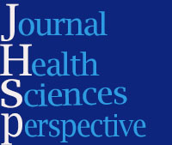

Identification of Factors Affecting the Health Development of Students: A Social Marketing Approach
Hamidreza Kazemi ¹, Mohammad Reza Esmaeili ², Farideh Ashraf Ganjouei ²
¹ Ph.D. Candidate in Sports Management, Islamic Azad University, Tehran Central Branch, Tehran, Iran
² Department of Sports Management, Islamic Azad University, Tehran Branch, Tehran, Iran

Article Info | A B S T R A C T
Article type:  Original article | Introduction: The purpose of this study was to identify factors affecting the health promotion of students using the approach of social marketing of sport. This is an applied research with a grounded theory paradigm.  Materials & Methods: The research approach is qualitative and its strategy is grounded data. The tactic used is latent content analysis. The research participants included experts in the fields of sport management and marketing as well as specialists in student sports who answered the research questions using purposeful sampling and snowball techniques. 14 members of the sample participated in in-depth and semi-structured interviews which served as the data collection tool. Using the inter-coder reliability method, the Kappa Cohen reliability score was calculated at 0.79. Data analysis was performed using open and axial coding processes of Corbin and Strauss and by utilizing Maxqda software version 2022.  Results: After analyzing and breaking down meaningful units, 109 primary statements with a total frequency of 489 were prepared for categorization and forming categories. Qualitative findings identified 7 main categories and 30 concepts as influential categories and concepts affecting the health promotion of students using the social marketing approach in sports. Research findings showed the category of individual and social empowerment with an importance coefficient of 117 and the category of culture-building with an importance coefficient of 103 had the highest importance coefficients among the categories.  Conclusion: Overall, given the analyses, it can be concluded that the social marketing approach in school sports can have a significant role in promoting the health of students.  Keywords: Healthcare and treatment, Screening and health monitoring, Individual and social empowerment, Health awareness and information, Facilities and infrastructures, Culture building, Motivation
Article History:
Received: Jan. 01, 2026
Revised: Feb. 02, 2026
Accepted: Fab. 27, 2026
Published Online: Mrch. 25, 2026
Correspondence to:
Mohammad Reza Esmaeili
Department of Sports Management, Islamic Azad University, Tehran Branch, Tehran, Iran
Email:
moh.esmaili@iauctb.ac.ir

- How to cite this paper
Kazemi H, Esmaeili MR, Ashraf Ganjouei F. Identification of Factors Affecting the Health Development of Students: A Social Marketing Approach. Journal of Health Sciences Perspective. 2026; 2(2):4-19.

Introduction
The education of students within a knowledge-based system that instills the necessary skills for regular exercise throughout their lives is of paramount importance. The cultivation of motivation by teachers and parents is crucial (Vizitiu, 2020). According to the report from the Centers for Disease Control and Prevention, participating in physical activities offers countless benefits to students, and physically active students tend to have better grades, school attendance, cognitive performance, and classroom behaviors (Olivari et al., 2023). Furthermore, students who have a physical activity plan from a young age reduce their risk of obesity, heart disease, high blood pressure, and other illnesses. Physical activity helps students sleep better and attain deeper sleep, contributing to post-exercise improvements in the body (Lang et al., 2023). Schools, as places where students spend a significant portion of their time, play a vital role in raising awareness about a healthy, physically active lifestyle. Moreover, schools can serve as a key element in implementing structured and unstructured programs to inform and engage students in physical activities, typically facilitated through physical education classes (Silva et al., 2018).
Physical education is an essential component of education and upbringing, facilitating the growth process in all dimensions of human existence through movement and physical activities and fostering the blossoming of talents. Its development paves the way for the cultivation and training of a healthy human workforce and is considered a part of national development programs (Ghannbari et al., 2018). Millions of children and adults engage in sports daily in schools and clubs worldwide. With a growing focus on a healthy lifestyle and lifelong participation, understanding how to develop and provide the best sports experiences in social sports is of paramount importance. School sports and physical education, as the oldest formal sports organizations in the country, have faced numerous challenges over the nearly century-long period since the commencement of formal activities. Thus, educational sports have not been recognized as a strong foundation for mass sports and championships in our country (Rasekh et al., 2018).
The primary goal in physical education and student sports is to promote a shift towards a healthy lifestyle among students. Today, social marketing is employed in the field of behavior change. This type of marketing differs significantly from commercial marketing, as social marketing organizations seek to persuade individuals to adopt new behaviors, reduce undesirable behaviors, or promote desirable ones (Dickson et al., 2018). In essence, social marketing can be considered a pathway to promoting behavior change (including increasing physical activity levels) that utilizes marketing tools for the delivery of social goods (Milicevic et al., 2022). Social marketing is a relatively new approach that has been utilized since 1971 to address societal issues, including health and environmental concerns, by applying marketing principles (Shams, 2018). Social marketing encompasses a set of tools (people, products, price, promotional activities, and place) with the ultimate goal of behavior change in the target audience (Eagle et al., 2017). Various studies have been conducted concerning physical activity and physical education in schools at different levels. Molina et al. (2016) investigated the ecological variables influencing the physical activity of adolescents in physical education classes. Dias et al. (2017) explored the relationship between school structure and physical activity in physical education classes.
Gorelikov (2023) emphasizes the need for sports wellness education among college students and suggests innovative ways to promote physical health and sports participation through media integration. Buhler et al. (2009) research focuses on the value of sports marketing media, such as social media, in developing athlete images and achieving positive sports marketing.
Manuilova et al. (2023) found that media marketing can increase student engagement in university sports club activities. Xian-Guo (2010) highlighted the promotional effects of university sports culture on the physical and mental health of students and their social integration. Limin (2014) emphasized the importance of school sports in promoting students' physical health and suggested integrating life education with physical education to achieve this goal. Dong Xiu (2008) focused on the role of sports participation in improving the mental health of students and recommended actions such as creating a coordinated sports culture on campus and enhancing students' social adaptation skills. The level of student participation in physical activities is not sufficiently high. According to the Centers for Disease Control and Prevention, less than one-fourth (24%) of children aged 6 to 17 engage in at least 60 minutes of physical activity daily. In 2017, only 26% of high school students engaged in at least 60 minutes of physical activity on all 7 days of the past week (Centers for Disease Control and Prevention, 2023). In our country, Iran, particularly in recent years following the COVID-19 pandemic, the health status of students on the one hand and excessive use of technology, mobile devices, and computer games on the other hand have become significant concerns.
Despite the extensive research conducted in recent years in the field of social marketing regarding individuals' participation in physical activities, it seems that there is still a lack of sufficient research on the role of this approach in the development of students' health. Research indicates that participating in physical education classes plays a positive role in encouraging young people to engage in physical activities with less concern about scheduling. Therefore, schools need to address physical education and physical activity management comprehensively. This approach is known as "comprehensive school physical activity programs" (Uddin et al., 2020).
Given the increasing role of technology in today's society and the trend towards reduced physical activity due to its proliferation, especially among children, we are witnessing a rise in sedentary lifestyles. Healthy children play a vital role in ensuring the future of a society. Therefore, adopting and implementing a healthy lifestyle at a young age is of great importance to them. Many children spend a significant amount of their time in school. However, developing sports, the necessity of physical activity, and education about a healthy lifestyle for students are of great significance.
Considering the influential role of social marketing in behavioral changes, it appears that one of the solutions for promoting sports among student groups is to utilize social marketing. Hence, this study aims to answer the question: What are the influential factors in the development of health in students using a social marketing approach?
Materials and methods
he research at hand falls under the category of applied research, as it seeks to apply its findings to the target audience. The researcher aims to use the results for practical application within the intended community (Newman, 2014). This study is conducted within the paradigms of constructivist and interpretive research, with an argumentative approach. The primary objective of this research is to identify the factors influencing the development of students' health using a social marketing approach. To achieve this goal, a combination of document analysis and fieldwork methods were employed. In-depth interviews were conducted with experts in the fields of sports management and marketing.
Analysis of experts' opinions during each of the interviews was carried out using the coding process, which Charmaz (2008) identifies as one of the best methods for qualitative data analysis (Wertz et al., 2011). The content analysis was performed through latent content analysis, and the MaxQDA software, version 2022, was utilized for this purpose. The researcher employed non-probabilistic and information-centric purposeful sampling to select a sample of 14 experts in the field. This study was conducted based on a data-driven approach, and the sample size was determined using targeted tactics, specifically the snowball sampling method (Corbin & Strauss, 1990).
According to Stemler (2000), reliability in content analysis refers to the consistency of the classification method used. This approach ensures that different individuals code the text to a consistent standard. This leads to reliable and replicable analyses of the text, making stability and repeatability in content analysis highly important. Kappa Cohen is a statistical measure of reliability that takes into account the probability of a chance agreement. It is a stronger measure of reliability compared to the percentage of agreement. Haney et al. (1998) suggest that a Kappa value of 0.70 or higher is generally considered to indicate good reliability in ranking. On the other hand, Kvalseth (1989) suggests that a Kappa coefficient of 0.61 indicates relatively good overall agreement.
Therefore, in the current research, to estimate the Cohen's Kappa coefficient, coding was done by two individuals at two one-month intervals to determine relative agreement and disagreement in the coding process. Using the formula:
$$k=\frac{Pa-Pc}{ Codes -pc}$$
In this formula, Pa represents the proportion of codes on which coders agree, and the value of pc represents the proportion of agreement.
Table 1. Calculating the kappa coefficient for the extracted codes and identified indicators
Interviewees | Total number of codes | Number of agreed upon codes (Pa) | Number of disagreements (Pc) | Kappa Cohen's coefficient
Interviewee 1 | 87 | 80 | 7 | 0.91
Interviewee 2 | 50 | 45 | 5 | 0.88
Interviewee 3 | 48 | 41 | 7 | 0.36
Interviewee 4 | 41 | 35 | 6 | 0.87
Total | 226 | 201 | 25 | 0.79

In the present study, as observed, the value of Cohen's Kappa is 0.88, which is significantly higher than 0.61. Therefore, the coding process demonstrates an acceptable level of reliability.
Results
The descriptive findings of the qualitative section of the study are presented in Table 2.
Table 2. The descriptive findings of the participants in the research.
Row | Age | Educational level | Field of study | Activity (years)
P1 | 50 | Ph.D. | Sports Management | 15
P2 | 62 | Ph.D. | Sports Management | 5
P3 | 44 | Master's degree | Physical Education | 11
P4 | 51 | Ph.D. | Sports Management | 12
P5 | 28 | Master's degree | Marketing | 14
P6 | 42 | Ph.D. | Sports Management | 13
P7 | 42 | Master's degree | Sports Management | 22
P8 | 42 | Master's degree |  | 22
P9 | 41 | Master's degree | Sports Management | 20
P10 | 42 | Ph.D. | Sports Management | 20
P11 | 47 | Ph.D. | Sports Management | 13
P12 | 51 | Ph.D. | Sports Management | 25
P13 | 60 | Ph.D. | Sports Management | 40
P14 | 31 | Bachelor's degree | Business Management | 12

After analyzing and breaking down the meaningful units, the initial code count was 139. Through a sequential review of the text and consultation with the supervisor and advisor, codes with repetitive, ambiguous, or irrelevant content were removed. Eventually, 109 initial codes, with a total frequency of 489 occurrences, were prepared for categorization and the formation of themes. A theme or category, according to Charmaz (2006), is essentially the same as the initial code categories in the form of abstract units with a higher degree, which can be created by placing several initial codes under a new name or focusing on multiple initial codes within the umbrella of another abstract unit.
Based on Schön's matrix (1), 7 main themes and 30 concepts related to the factors affecting the development of students' health with a social marketing approach to sports have been identified and enumerated. The main theme "Health Screening and Monitoring" includes concepts like demographic characteristics and health screening. The main theme "Healthcare and Treatment" encompasses concepts such as mental health and coping with depression, risk and threatening factors, healthcare providers, social differences in health, mental health disparities, prevention and treatment, dietary habits, and specialist counseling. The main theme "Individual and Social Empowerment" consists of concepts like family involvement, individual empowerment, behavior change, creating social changes in students, participation in school decisions, social and interactive skills. The main theme "Education and Information" involves concepts like educational media, teaching tools, physical activity education, nutrition education, health awareness, and health education. The main theme "Facilities and Infrastructure" includes concepts like creating sports infrastructure and accessibility facilitation. The main theme "cultivation" encompasses concepts related to the culture of health in schools, participation in sports and physical activity, lifestyle changes and their effects, regional and cultural differences. The main theme "motivation" includes concepts such as social identity and motivation, modeling, encouragement, and partial motivation. The figure below illustrates the number of concepts, frequencies, and distribution of concepts and initial codes across the interviews.
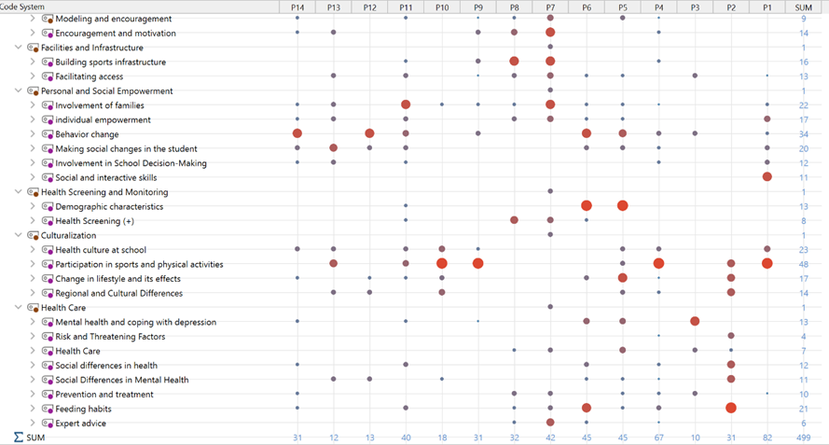
Figure 1. Schön Matrix of Themes and Concepts Influencing Health Development with a Social Marketing Approach.

In the "Education and Information" theme, the concepts of "Educational Media" and "Nutrition Education" had the highest importance coefficients, with values of 27. In the "Motivation Creation" theme, the concept of "Encouragement and Motivation" had an importance coefficient of 14, and in the "Facilities and Infrastructure" theme, the concept of "Infrastructure Development" had an importance coefficient of 16. In the "Individual and Social Empowerment" theme, the concepts of "Behavior Change" and "Family Participation" had importance coefficients of 34 and 22, respectively. In the "Health Screening and Monitoring" theme, the concept of "Demographic Characteristics" had an importance coefficient of 13. In the "Culturalization" theme, the concepts of "Participation in Sports and Physical Activities" had the highest importance coefficient of 48, followed by "Dietary Habits" and "Mental Health and Coping with Depression" with importance coefficients of 21 and 13, respectively.
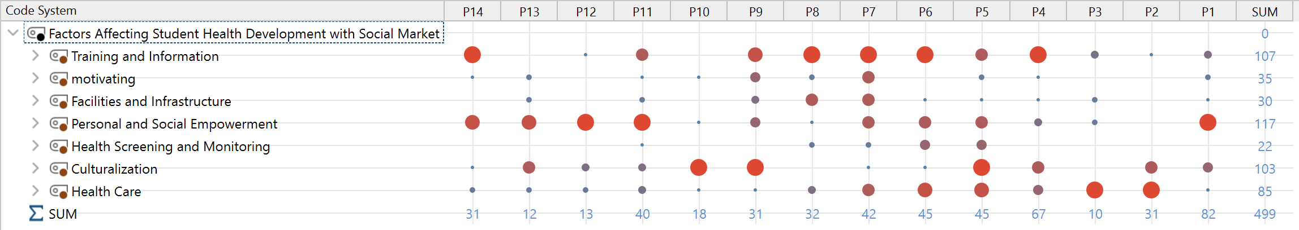
Figure 2. Shonan Matrix of Main Influential Concepts on Students' Health Development with a Social Marketing Approach in Sports.

In Figure 2, it can be observed that among the influential concepts on students' health development using a social marketing approach in sports, the "Individual and Social Empowerment" category had an importance coefficient of 117, and the "Culturalization" category had an importance coefficient of 103, making them the most significant categories among the others. The frequencies of codes, concepts, and categories extracted from the interviews were further examined.
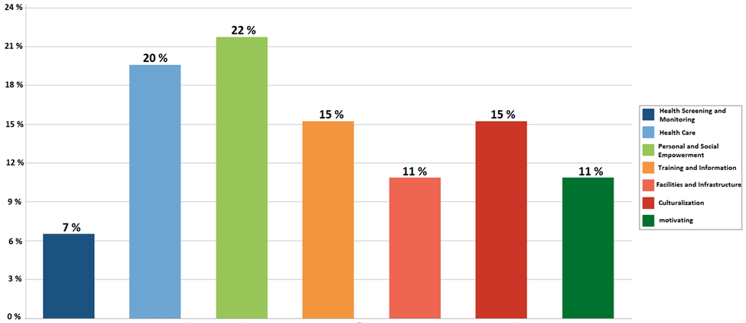
Figure 3. Frequency Diagram of Categories, Concepts, and Codes Based on the Experts' Opinions in the Study.

As seen in Figure 3, the "Individual and Social Empowerment" category with a frequency of 24% and, following that, the "Healthcare and Medical Care" category with a frequency of 20% held the highest rankings among the content analysis of the interviews. Further, for the clarification and examination of the primary statements, concepts, and categorized themes concerning the development of students' health using a social marketing approach, the following table is provided:
Table 3. Initial statements, concepts, and influential factors on the development of students' health using a social marketing approach in sports.
Table 3. The descriptive findings of the participants in the research
Key Concepts | Concepts | Initial statements
Screening and Health Monitoring | Demographic Characteristics | Physiological factors, family and individual's upbringing environment, urban or rural residence, individual's living conditions, ethnicity and race, individual's social class, gender, and age
Screening and Health Monitoring | Health Screening (+) | Monitoring health indicators, medical tests, BMI screening
Healthcare and treatment measures | Mental health and depression prevention | The importance of mental health in enhancing the quality of life, the impact of depression on mental health and psychology, the promotion of coping strategies for depression, and the improvement of psychological well-being.
Healthcare and treatment measures | Risk and threat factors | Differences in the impact of risk factors in different communities, alcohol and smoking consumption as risk factors.
Healthcare and treatment measures | Healthcare measures | Promoting awareness of personal and social health care, risk factors in physical and mental health, oral and dental health care, social differences in healthcare, social differences in access to healthcare services, the economic role in influencing overall community health.
Healthcare and treatment measures | Social disparities in health | Financial problems and obstacles in accessing healthcare services.
Healthcare and treatment measures | Social disparities in mental health | Examples of cultural and behavioral differences in social life, psychological differences among different social strata, the impact of social and economic factors on mental health.
Healthcare and treatment measures | Prevention and treatment | The importance of different nutrients in preventing common diseases, increasing awareness of disease prevention methods, and addiction prevention.
Healthcare and treatment measures | Dietary habits | Weight control, differences in nutritional attitudes in different countries and regions, the impact of food quality on physical health, dietary habits in various social strata, differences in dietary patterns based on social and economic status, the influence of nutrition and dietary regimes on health.
Healthcare and treatment measures | Specialized counseling | Vaccination, social and psychological support, nutritional counseling.
Individual and social empowerment | Family participation | Promoting family engagement in students' health, fostering a culture of sports and physical activity in schools and families, conducting family education classes.
Individual and social empowerment | individual empowerment | Positive interaction with peers, developing communication skills, negotiation skills, promoting mental health, self-care empowerment.
Individual and social empowerment | behavior change | Changing individuals' thoughts and motivations regarding health, promoting positive changes in students' health habits, promoting regular exercise, healthy nutrition, and health behaviors, changing harmful habits like smoking.
Individual and social empowerment | creating social changes in students | Encouraging students to participate in creating positive changes in the school environment, fostering positive social changes by students, encouraging participation in school social activities.
Individual and social empowerment | involvement in school decision-making | Encouraging participation in school decision-making groups (+), influencing students in school policies and programs.
Individual and social empowerment | social and communication skills | Developing teamwork and collaboration skills, enhancing conflict resolution skills, strengthening social problem-solving skills, understanding social strengths and weaknesses.
Education and information dissemination | Educational media | Using marketing techniques in the digital world, utilizing platforms and communication channels, organizing health festivals, providing positive role models in health and sports, broadcasting health-focused advertisements.
Education and information dissemination | Educational tools | Using national media, utilizing social media, designing educational posters.
Education and information dissemination | physical activity education | Promotion of regular exercise and physical activities (+), participation in sports programs and sports clubs, compulsory education in physical education classes (+), awareness of the health benefits of sports.
Education and information dissemination | nutrition education | Changing dietary habits towards healthier options (+), strategies for developing social marketing in increasing awareness of nutritional value, teaching concepts of health and healthy nutrition in schools, promoting knowledge about healthy nutrition, teaching healthy nutrition.
Education and information dissemination | health awareness and training | Increasing awareness of health and a healthy lifestyle in society (+) (+), education about the harmful effects of drugs, promoting health knowledge, health education in schools.
Facilities and infrastructure | Establishing sports infrastructure | Creating healthy sports and recreational facilities in neighborhoods, establishing sports clubs, developing green spaces and parks, building playgrounds and sports fields.
Facilities and infrastructure | facilitating access | Membership discounts at sports clubs, access to sports facilities, and access to neighborhood and public parks.
Cultural promotion | Promotion of a culture of health in schools | Promoting a culture of health in schools, creating a conducive environment for health in schools, and promoting healthy habits in schools.
Cultural promotion | participation in sports and physical activities | Differences between regions in embracing sports and promoting an active lifestyle, the culture and sporting habits in different areas, the impact of sports and physical activity on physical health, outdoor and nature-based physical activities, organizing sports competitions and contests in schools, encouraging active participation in sports programs, promoting involvement in school sports teams, supporting school sports teams.
Cultural promotion | lifestyle changes and their effects | Precise sampling and its significance in analyzing social differences, comparing lifestyles in different regions, the impact of lifestyle changes on physical and mental health.
Cultural promotion | regional and cultural differences | Differences between urban and rural areas in daily life, the impact of changing residence on people's behaviors and habits, regional variations in cultural teachings and lifestyles, motivation for change.
Creating motivation | Social identity and motivation | Self-awareness development, increasing motivation for social participation, social identity development.
Creating motivation | Modeling and encouragement | Role modeling athletes, role modeling successful individuals in the field of health.
Creating motivation | Encouragement and motivation | Holding sports competitions and tournaments in schools, encouraging students to participate in group sports activities, awarding prizes to top athletes.

After analyzing the content of texts and conducted interviews and going through the process of coding and summarizing the initial codes, the central and main themes of the model for factors influencing the development of students' health using a social marketing approach in sports, taken from the MAXQDA software environment, version 2022, are presented in Figure 4.
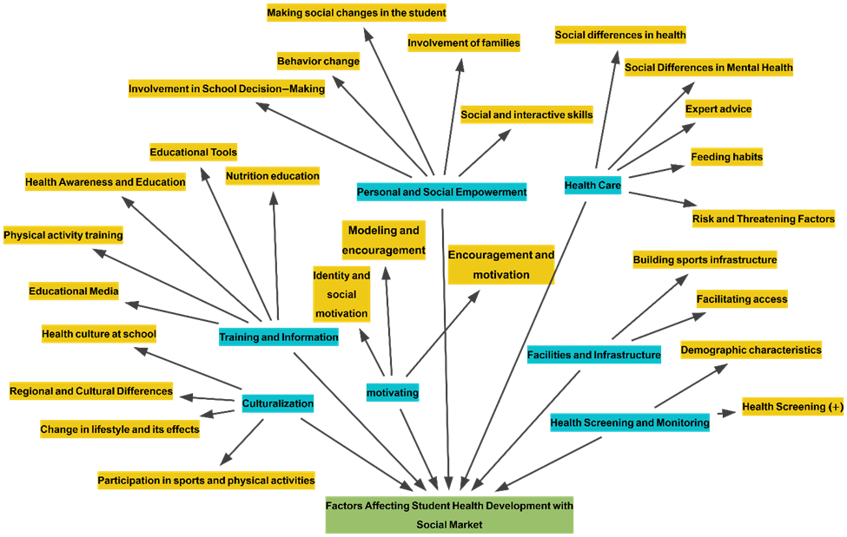
Figure 3. A tree diagram of the factors influencing the development of students' health with the role of social marketing in sports.

Conclusion
The importance of promoting physical activity in schools, families, and communities, especially given the increasing rates of overweight, obesity, and type 2 diabetes in children, has been emphasized by NICE (National Institute for Health and Care Excellence) (Ha, 2019). Considering the amount of time children spend in schools and its impact on them, schools provide a unique opportunity for promoting and implementing physical activity, which is crucial for the health of future generations (Jackson et al., 2020). Schools are crucial environments for promoting healthy behaviors like physical activity, and they should implement comprehensive programs to strengthen existing research in the field of physical activity (Abanda & Josiane, 2020). While physical education classes have traditionally been seen as the primary source of physical activity, schools can provide unique opportunities for behavior change. The school environment has the potential to increase levels of physical activity by changing beliefs, providing education on the health benefits, facilitating participation, and boosting self-efficacy (Ha, 2019).
In the results of the content analysis of interviews with experts, 119 initial statements were coded and categorized a total of 489 times, ultimately resulting in 7 main themes and 30 concepts as influential factors in the development of students' health using the social marketing approach in sports. Among these, the theme of individual and social empowerment with an importance coefficient of 117 and the theme of culture with an importance coefficient of 103 had the highest importance coefficients among the themes. Furthermore, in the section of categorized concepts, the concept of educational media and nutrition education each had an importance coefficient of 27, the concept of encouragement and motivation with an importance coefficient of 14, the concept of creating infrastructures with an importance coefficient of 16, the concepts of behavior change with an importance coefficient of 34, and family participation with an importance coefficient of 22, the concept of demographic characteristics with an importance coefficient of 13, the concepts of participation in sports and physical activity with an importance coefficient of 48, the concepts of dietary habits with an importance coefficient of 21, and mental health and coping with depression with an importance coefficient of 13 had the highest importance coefficients.
The qualitative results of the research showed that one of the influential themes in the development of students' health was the theme of "Health Screening and Monitoring." This finding is in line with the results of studies conducted by McPherson et al. (2013), and Corriveau et al. (2014). Based on these findings, health screening and monitoring programs in schools can provide students and their families with information about health risks and healthy lifestyle solutions. This information may assist students and their families in engaging in physical activity and adopting healthier lifestyles. McPherson et al. (2013) also stated that school health screening programs can provide information about health risks and promote a healthy lifestyle, encouraging students to engage in physical activity. Corriveau et al. (2014) observed improvements in cardiovascular parameters and healthy behaviors among middle school students during a four-year intervention project in Healthy Schools in Michigan. These programs not only identify health issues that may not be apparent to parents or teachers but also aid in the assessment and evaluation of screening programs.
In the present study, the concepts related to the health monitoring and screening domain include demographic characteristics and health monitoring. Conducting examinations in schools allows for the early detection of health issues such as obesity, diabetes, or high blood pressure, enabling students to receive appropriate care and referrals in the early stages. Early intervention expedites the improvement of outcomes. Furthermore, the data collected from screenings and health monitoring in schools enables them to understand the health trends within their student population and design targeted physical readiness and health enhancement programs to meet their specific needs. When supported by social marketing campaigns that promote physical activity, school health monitoring and screening can normalize and encourage participation in sports, sports programs, and other active recreational activities. Over time, school health initiatives can promote a culture of health, physical activity, and well-being among students, families, and the broader community by instilling healthy habits at a young age. Research by Keeley et al. (2009) and Teferi et al. (2020) suggests that physical activity and fitness improve cognition, memory, focus, mood, and academic performance in students. Therefore, monitoring programs can support learning outcomes.
Another discovered influential factor from content analysis and categorization of concepts and codes was the issue of healthcare. This encompassed concepts such as mental health and depression, risk factors and threats, healthcare, social differences in healthcare, social differences in mental health, prevention and treatment, dietary habits, and specialized counseling. This finding aligns with the results of the research by Rezai and Kashavarz (2014) and Alissa (2020). School health programs that incorporate social marketing principles play a significant role in enhancing health competencies and promoting healthy behaviors among students (Rezai and Kashavarz, 2014). Alissa (2020) emphasizes the importance of implementing health education in schools to combat childhood obesity and promote healthy lifestyle choices. These school health service programs aim to educate students about the information and skills necessary for health literacy, maintaining and improving their health, preventing diseases, and reducing risky behaviors that impact health (Ami et al., 2012). Access to mental health services can assist students in managing anxiety, depression, and eating disorders while facilitating an active lifestyle. Students' engagement with community health resources, sports programs, and recreational centers reinforces healthy behaviors. Additionally, providing health services to families encourages an active lifestyle at home. Data from students' health care can improve school policies and health initiatives related to physical education, nutrition, and daily activity time. Overall, health care, as part of the school culture and social marketing, creates a supportive system for students to continuously engage in physical activities and cultivate healthy habits throughout their lives.
Another factor that was discovered and identified by experts as an influential factor in the development of students' health is the concept of individual and social empowerment. Empowering students individually and socially, as one of the features of social marketing in sports, can have a positive impact on the health growth of students. Empowerment works towards social change and is achieved through social actions that can improve health outcomes for students (Wenzel et al., 1999). For example, the Sunshine sports program aims to improve the physical health of college students by integrating education, training, and competition in physical education courses (Weber-Rajek et al., 2015). In general, enhancing the individual and social capabilities of students through sports can have a positive impact on their health and well-being. By promoting healthy behaviors and attitudes, social marketing in sports can help students establish lasting habits that support their health and well-being (Demirtaş, 2021). Morozov et al. (2018) emphasized the importance of mass sports activities, self-regulation of students' health, and the improvement of their physical movement and overall health. Student involvement in designing and leading health-promoting activities enhances their creativity, energy, and social influence. In this study, indicators of individual and social capabilities, such as positive peer interactions, the development of communication skills, negotiation skills, and the promotion of mental health, have a positive impact on students' health development. These results demonstrate that enhancing students' individual and social capabilities can lead to improvements in their health and well-being and can assist schools and policymakers in planning and implementing school health programs.
The concept of education and information dissemination, including elements such as educational media, teaching tools, and health awareness and literacy, is significant as part of social marketing in sports. This aspect can assist students in making informed and health-conscious decisions (Bayramoglu et al., 2018). By providing knowledge and skills related to sports and healthy behaviors, social marketing in sports can help students establish lasting habits that support their health and well-being (Centers for Disease Control and Prevention, 2013). Hristov (2017) emphasized that sports education is a social factor for promoting health and overall physical development in students.
Educational campaigns and materials designed by students increase engagement, retention, and the likelihood of behavior change. Furthermore, educating students about issues such as concussion management, eating disorders, substance use, alcohol, mental health, and more improves health literacy and early intervention (Kroshus et al., 2015). Education and information dissemination are key elements in social marketing in sports, and they have a significant impact on the development of students' health. Education and information in the field of health and nutrition play a crucial role in improving students' health. These actions allow them to change unhealthy dietary habits and adopt a healthy lifestyle. Additionally, they promote the development of communication skills, negotiation skills, and positive interactions among students. Ultimately, education and information contribute to the improvement of students' health and well-being.
Another influential factor in health development from the perspective of experts in the research is the concept of facilities and infrastructure, within the framework of social sports marketing. Facilities and infrastructure, as part of social marketing, encompass concepts related to creating sports facilities and facilitating access. They can help students engage in regular physical activities and participate in sports. This finding aligns with the results of research conducted by the Centers for Disease Control and Prevention (2013) and Chu (2021).
By providing safe and suitable spaces and resources, social sports marketing can help students develop lifelong habits that support their health and well-being (Centers for Disease Control and Prevention, 2013). Chu's research (2021) demonstrates that the facilities and infrastructure of educational institutions, coupled with social marketing strategies, play a significant role in promoting the health of students and scholars. The presence of indoor and outdoor spaces, fields, tracks, sports halls, and pools provides opportunities for participation in sports and fitness activities throughout the year, promoting an active lifestyle.
Furthermore, the presence of modern amenities such as changing rooms, hydration stations, workout spaces, and healthy food options in sports facilities directly facilitates healthy behaviors. Collaboration with clubs, recreational centers, and health facilities provides greater access to resources for sports programming, health education, and related health services. Facilitating access to sports facilities encourages students to participate in sports and promotes the adoption of healthy habits throughout life. These actions also improve the return on investment in public health within the community.
One of the highly important and influential factors in the development of students' health in this research is the concept of culturalization. This concept includes notions such as the culture of health in schools, participation in sports and physical activities, lifestyle changes, and regional and cultural differences and effects. Culturalization, as one of the features of social marketing in sports, can have a positive impact on the health of students. Immigrant students in Spain and Chile reported positive beliefs about the correlation between school sports and health development in various dimensions (Carter-Thuillier et al., 2017). It also explores the resources of physical education in health, entertainment, society, and culture. Sports participation among immigrants provides opportunities for preserving cultural identity and gaining social capital (Xu, 2007). Libo (2021) emphasizes the importance of cultural sports information exchange and recreation for empowering students and promoting sustainable cultural sports development. In the current research, it has also been acknowledged by experts that fostering a pervasive and equitable sports culture among students helps them feel a sense of acceptance, value, and emotional/physical security. This contributes to psychological well-being and overall welfare.
Furthermore, emphasis on sportsmanship, teamwork, discipline, respect, and sports ethics contributes to the development of a strong personality and transferable leadership skills in the context of health. On the other hand, linking sports/culture to cultural traditions or involving the family/community fosters healthy behaviors in assets and cultural identities. According to Kroshus et al. (2015), addressing harmful norms in sports culture regarding issues like bullying, substance abuse, violence, eating disorders, or excessive competition reduces health-risk behaviors. In summary, a pervasive and thoughtful cultural environment surrounding school sports can shape students' personal growth, relationships, identity, and developmental pathways powerfully, resulting in lifelong positive health outcomes.
The last concept that emerged in this research through content analysis of interviews was the concept of motivation, which includes social identity, motivation, modeling, encouragement, and motivation enhancement. The results of this study demonstrate that fostering motivation in students is a key pathway through which social marketing in sports can have a positive impact on health outcomes. Research has shown that implementing a sports education curriculum model using the self-determination theory can increase students' motivation for sports (Chu et al., 2018). It has been identified that the sports education model has positive and consistent effects on adolescent motivation (Méndez-Giménez et al., 2021). Additionally, a study on university sports programs showed that reasons for student participation in sports include work-life balance, physical fitness, body image, social interaction, and entertainment, all of which contribute to overall health and well-being of students (Diehl et al., 2018). Teachers and coaches play a crucial role in fostering motivation among students in sports activities and promoting their health.
They encourage students to be more enthusiastic and put in extra effort by adopting positive attitudes and emphasizing the enjoyment of physical activities. Teachers' ability to motivate students to take on leadership roles in sports and health by promoting self-confidence and recognizing students' abilities leads to increased self-esteem. Furthermore, sports, through creating group connections and social interactions, enhance motivation for participation in social activities and contribute to the formation of a positive identity among students. Providing positive role models in sports and successful athletes can increase students' motivation to pursue success. Additionally, healthy competitions can boost motivation for progress and achievement. Participation in group activities can also reinforce motivational abilities, and ultimately, rewards and recognition for students can increase motivation for continued participation in sports activities.
In a general summary, based on the analyses conducted, it can be concluded that the social marketing approach in school sports can play a significant role in the development of students' health. Factors such as health care and monitoring, individual and social empowerment of students, raising awareness and health education, suitable sports facilities and infrastructure, promoting a positive cultural context, creating motivation among students, and emphasizing the educational and developmental aspects of sports can all lead to the adoption of a healthy lifestyle by students and, consequently, the enhancement of their health. Therefore, it is essential for school sports policies and planning to adopt a social marketing approach, taking into account these key factors.

References

- Abanda, G., & Josiane, B. (2020). Tick-borne pathogens in African cattle–novel molecular tools for diagnostics in epizootiology and the genetics of resistance (Doctoral dissertation, Universität Tübingen).
- Alissa, N. A. (2021). Social barriers as a challenge in seeking mental health among Saudi Arabians. Journal of Education and Health Promotion, 10.
- Bayramoglu, Z., Kebudi, R., Yilmaz, R., Buyukkapu Bay, S., Kebudi, A., Karanlik, H., & Adaletli, I. (2018). Primary rhabdomyosarcoma of the breast: imaging findings and literature review. Breast Care, 13(4), 293-297.
- Buhler, A., & Nufer, G. (2012). Relationship marketing in sports. Routledge.
- Carter-Thuillier, B., López-Pastor, V., & Gallardo-Fuentes, F. (2018). Relación entre salud y deporte escolar desde una perspectiva intercultural, UN estudio multicaso. Revista de la Facultad de Medicina, 66(1), 37-43.
- Castelli, D. M., Barcelona, J. M., Crim, B., & Burson, S. L. (2020). The Importance of Providing Opportunities for Health Behaviors during the School Day. Building Future Health and Well-Being of Thriving Toddlers and Young Children, 95, 145-155.
- Centers for Disease Control and Prevention. (2010). The Association Between School-Based Physical Activity, Including Physical Education, and Academic Performance. Atlanta, GA; Centers for Disease Control and Prevention, US Department of Health and Human Services.
- Centers for Disease Control and Prevention. (2023). The Physical Activity Guidelines for Americans, 2nd edition recommend that children and adolescents ages 6 to 17 years do 60 minutes or more of moderate-to-vigorous physical activity daily.
- Charmaz, K. (2008). Reconstructing grounded theory. The SAGE Handbook of Social Research Methods, 461-478.
- Chu, T. (2021). The influence of sports on health science and its factors. Revista Brasileira de Medicina do Esporte, 27, 327-330.
- Chu, T. L., & Zhang, T. (2018). Motivational processes in Sport Education programs among high school students: A systematic review. European Physical Education Review, 24(3), 372-394.
- Corbin, J. M., & Strauss, A. (1990). Grounded theory research: Procedures, canons, and evaluative criteria. Qualitative Sociology, 13(1), 3-21.
- Corriveau, N., Eagle, T., Jiang, Q., Rogers, R., Gurm, R., Aaronson, S., & Jackson, E. A. (2015). Sustained benefit over four-year follow-up of Michigan’s project healthy schools. American journal of public health, 105(12), e19-e25.
- Demirtaş, Ö. (2022). El efecto de la educación deportiva en el comportamiento de estilo de vida saludable de los estudiantes universitarios. Apuntes Universitarios.
- Dias, A. F., Lemes, V. B., Brand, C., Mello, J. B., Gaya, A. R., & Gaya, A. C. A. (2017). Association between school structure and physical activity in physical education class and school recess. Revista Brasileira de Cineantropometria & Desempenho Humano, 19, 164-173.
- Dickson, G., O'Reilly, N., & Walker, M. (2018). Conceptualizing the dissolution of a social marketing sponsorship. Journal of Global Sport Management, 3(2), 146-169.
- Diehl, K., Fuchs, A. K., Rathmann, K., & Hilger-Kolb, J. (2018). Students’ motivation for sport activity and participation in university sports: A mixed-methods study. BioMed research international, 2018.
- Dong-xiu, Z. (2008). A Study on Sports Participation and the Promotion of the Development of College Students' Psychological Health.
- Eagle, L., Osmond, A., McCarthy, B., Low, D., & Lesbirel, H. (2017). Social marketing strategies for renewable energy transitions. Australasian Marketing Journal, 25(2), 141-148.
- Ghanbari, S., Shafinia, M., Ali Zadeh, N. (2018). Pathology of Physical Education and School Sports using the Triangular Model. Research in Sport Pedagogy, 15, 139-160.
- Gorelikov, V. A. (2023). Objects of marketing in college sports. Physical Education and Collegiate Sports, 2(2), 143-150.
- Ha, A. S., Ng, J. Y., Lonsdale, C., Lubans, D. R., & Ng, F. F. (2019). Promoting physical activity in children through family-based intervention: Protocol of the “Active 1+ FUN” randomized controlled trial. BMC Public Health, 19, 1-12.
- Haney, W., Russell, M., Gulek, C., & Fierros, E. (1998). Drawing on Education: Using Student Drawings to Promote Middle School Improvement. Schools in the Middle, 7(3), 38-43.
- Hristov, P. (2017). The need for sports skills among students. In Conference Proceedings. 335-339.
- Jackson, J. K., Jones, J., Nguyen, H., Davies, I., Lum, M., Grady, A., & Yoong, S. L. (2021). Obesity prevention within the early childhood education and care setting: a systematic review of dietary behavior and physical activity policies and guidelines in high income countries. International journal of environmental research and public health, 18(2), 838.
- Keeley, T. J., & Fox, K. R. (2009). The impact of physical activity and fitness on academic achievement and cognitive performance in children. International review of sport and exercise psychology, 2(2), 198-214.
- Kroshus, E., Garnett, B., Hawrilenko, M., Baugh, C. M., & Calzo, J. P. (2015). Concussion under-reporting and pressure from coaches, teammates, fans, and parents. Social science & medicine, 134, 66-75.
- Kvalseth, T. O. (1989). Note on Cohen’s kappa. Psychological Reports, 65, 223-226.
- Lang, J. J., Zhang, K., Agostinis-Sobrinho, C., Andersen, L. B., Basterfield, L., Berglind, D., & Fraser, B. J. (2023). Top 10 international priorities for physical fitness research and surveillance among children and adolescents: a Twin-Panel Delphi study. Sports Medicine, 53(2), 549-564.
- Libo, M. (2021). The Influence of Sports Culture Transmission on the Development of Health Education from the Perspective of "Internet +". Francis Academic Press, UK. 768-773.
- Limin, P. (2014). Research on the Development of School Sports with Physical Health as a Starting Point. In 2014 2nd International Conference on Advances in Social Science, Humanities, and Management (ASSHM-14). 362-365.
- Manuilova, K. A., & Tokarczuk, Y. A. (2023). The influence of media marketing on incrasing student’s engagement in the activitice of student sports clubs. Physical Education and Collegiate Sports, 2(2), 151-157.
- McPherson, B., & Driscoll, C. J. (2014). School Health Screening: History, Principles and Analysis. School Health Screening Systems, 3.
- Méndez-Giménez, A., del Pilar Mahedero-Navarrete, M., Puente-Maxera, F., & de Ojeda, D. M. (2022). Effects of the Sport Education model on adolescents’ motivational, emotional, and well-being dimensions during a school year. European Physical Education Review, 28(2), 380-396
- Milicevic, N., Djokic, I., Djokic, N., & Grubor, A. (2022). Social Marketing in Promoting Sustainable Healthy Lifestyle among Student Population. Sustainability, 14(3), 1874.
- Molina-García, J., Queralt, A., Estevan, I., & Sallis, J. F. (2016). Ecological correlates of Spanish adolescents’ physical activity during physical education classes. European Physical Education Review, 22(4), 479-489.
- Morozov, A., Panachev, V., Opletin, A., Zelenin, L., & Filatov, A. (2020). Educational ambience as facility to successful socialization students. In BIO Web of Conferences (Vol. 26, p. 00087). EDP Sciences.
- Newman, J. (2014). Revisiting the “two communities” metaphor of research utilisation. International Journal of Public Sector Management, 27(7), 614-627.
- Olivari, B. S., Jeffers, E. M., Tang, K. W., & McGuire, L. C. (2023). Improving brain health for populations disproportionately affected by Alzheimer’s disease and related dementias. Clinical Gerontologist, 46(2), 128-132.
- Rasekh, N., Sajjadi, A., Razavi, M.H., Dosti, M. (2018). Structural analysis of educational exercise in Iran. Research in Sport Education, 6(14), 17-44.
- Rezaei-Pandari, H., & Keshavarz-Mohammadi, N. (2014). Social marketing approach in health care: A review study. Iranian Journal of Health Education and Health Promotion, 2(2), 109-130.
- Shams, M. (2018). Social marketing for health: Theoretical and conceptual considerations. Selected issues in global health communications, 43-55.
- Silva, D. A. S., Chaput, J. P., Katzmarzyk, P. T, Fogelholm, M, Hu, G, Maher, C, ... & Tremblay, M. S. (2018). Physical education classes, physical activity, and sedentary behavior in children. Medicine & Science in Sports & Exercise, 50(5), 995-1004.
- Stemler, S. (2000). An overview of content analysis. Practical Assessment, Research, and Evaluation, 7(1), 17.
- Teferi, G. (2020). The effect of physical activity on academic performance and mental health: systematic review. American Journal of Science, Engineering and Technology, 5(3), 131.
- Uddin, R, Salmon, J, Islam, S. M. S, & Khan, A. (2020). Physical education class Participation is associated with physical activity among adolescents in 65 countries. Scientific Reports, 10(1), 22128.
- Vizitiu, E. (2020). Study on the importance of physical education and sport classes in current society – investigative approach. Luminița–Eugenia AVRAM1, 8(2), 28-33.
- Weber-Rajek, M., Baumgart, M., Michalski, A., Radzimińska, A., Goch, A., Lulińska-Kulik, E., & Zukow, W. (2015). Students’ health behaviors–own research= Zachowania zdrowotne studentów–badania własne. Journal of Education, Health and Sport, 5(9), 647-662.
- Wenzel, E., Erben, R., & Franzkowiak, P. (1999). People empowerment vs social capital: from health promotion to social marketing. Health Promotion Journal of Australia: Official Journal of Australian Association of Health Promotion Professionals, 9(3).
- Wertz, F. J. (2011). Five ways of doing qualitative analysis: Phenomenological psychology, grounded theory, discourse analysis, narrative research, and intuitive inquiry. Guilford Press.
- Xian-guo, H. (2010). Reflection on the Impact of Campus Sport Culture on College Students' Socialization. Journal of Guangdong University of Technology.
- Xu, Lei. (2007). An Analysis of "the Sunshine Sports Program" and Research of the Tactics of Its Execution in Colleges and Universities. Journal of Capital Institute of Physical Education.
- Zhou, Y, & Wang, L. (2019). Correlates of physical activity of students in secondary school physical education: a systematic review of literature. BioMed Research International, 2019.

